Building an EMAS Pump

EMAS stands for Escuela Móvil de Agua y Saneamiento (Spanish for “Mobile School for Water and Sanitation”). EMAS is a school with one teacher, who is also its director and the designer/inventor of the “EMAS technology”: Wolfgang Buchner, a German citizen living in Bolivia (South America).

EMAS technology has become a concept: it stands for cheap and simple, yet sturdy and very effective solutions in rural water supply and sanitation. The idea is to provide designs that can be built with materials available in hardware stores anywhere in the world, using relatively simple tools, in rural environments, and therefore can easily be copied by poor people in the developing world.

The EMAS water pump is one of the brightest exponents of this philosophy.

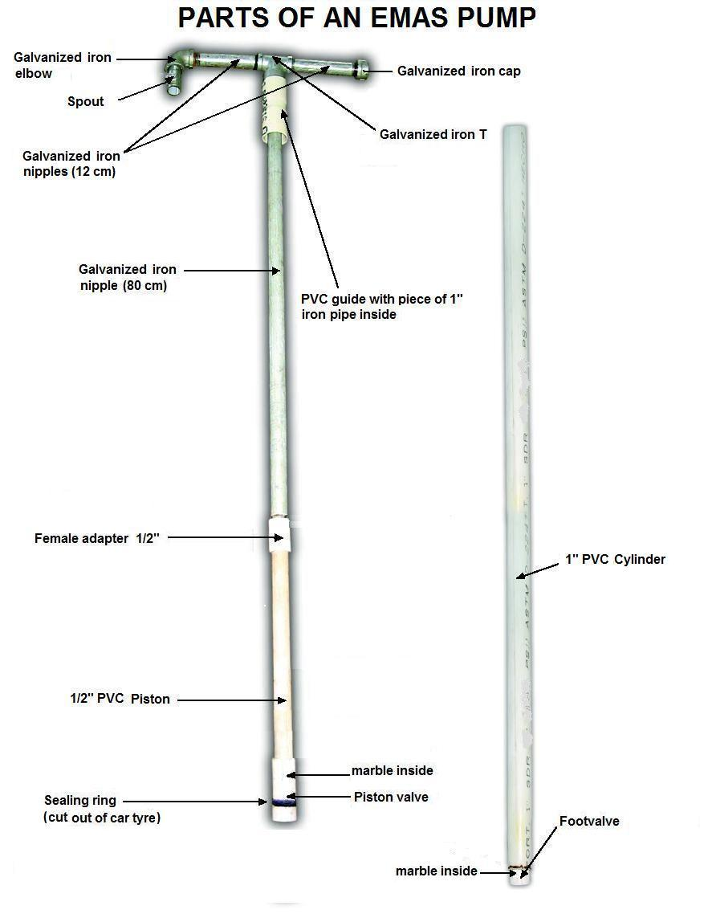
What you see here is a piston pump that delivers such pressure that it can overcome a head of 40 meters. That means it can pump water from say 20 meters underground directly to an elevated tank another 20 meters above the ground level. Yet, it is easy to build from simple PVC pipes, adapters and (galvanized) iron tubes available in any hardware store.

It works by compressing water between two one-way valves (check valves): the footvalve and the piston valve. Water is forced up the piston tube and comes out from the handle.

DOWNSTROKE |  | UPSTROKE
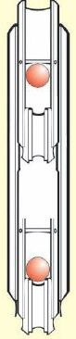 | Piston  Pin: prevents marble from moving more than 1 cm  Marble  Piston valve  Cylinder  Pressure chamber  Footvalve  When the piston moves down, the footvalve closes.  Increaing pressure in the chamber forces open the piston valve and water is pushed into the piston | 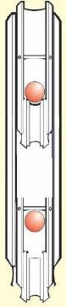 | Water flow  When the piston moves up, the piston valve closes, and the water in the piston is lifted.  Negative pressure between both valves pulls the footvalve open and water flows into the chamber.

Contrary to most other piston pumps, water comes out on downstroke, and most often no lever is installed.

What do we need ?

The complete toolset to build this pump is pictured here:

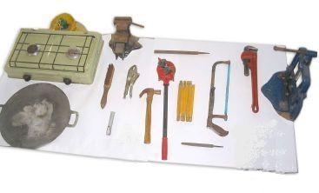 | A gas stove (optional)  A thick sheet of metal (preferrably aluminum)  A table screw  A metal file  A plier  A knife  A metal hacksaw  A measuring tape  A hammer  A Stillson wrench (optional)  A pipe screw (optional)  A pipe threading tool (optional)
First, we build the two valves (footvalve and piston valve).

An EMAS valve is made of a male and a female PVC adapter (1/2 inch) and a glass marble ().

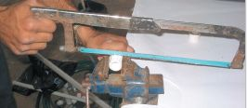 | 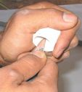
Cut the thread off the female adapter | Clean the non-threaded part with a knife
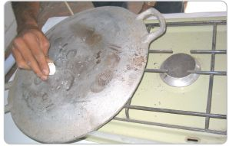 | 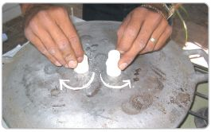
Heat the metal (aluminum) sheet.  Test the temperature with a piece of PVC. The plate should not be so hot as to “burn” the PVC (turning it brown). | Heat the edges of the male adapter (right) and the piece cut off the female adapter (left), turning them around their axis on the hot plate, until they turn around easily in their own melt.
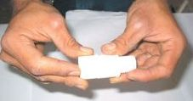 | “Weld” the pieces together, pushing the hot molten surfaces firmly against each other.  The result is still a male adapter, but twice as long as a normal one.
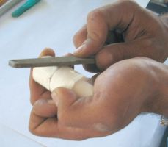 | 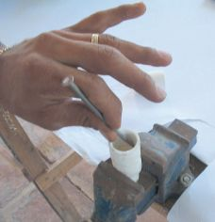
File off any protruding plastic on the outside and cut out any on the intside
Cutting out protruding PVC inside the workpiece is delicate. Make sure you do not damage the seat of the marble or the valve will never seal correctly. Here it is done with a self-made small chisel, made of a large nail. Hammer the nailpont flat and sharpen it with a file. You can make a bigger (semi round) chisel from a piece of ¼” concrete iron.

Now we need something that will retain the marble. It should not be allowed to move more than about 1 cm from its seat. This can be accomplished simply inserting a pin across the valve (like in the diagram above). But it is better to build a “retainer” from PVC pipe, as follows:

First, make a piece of reinforced (double) PVC tube, either of these two ways:
- glue a piece (1-2 cm) of ½” CONDUIT pipe (used in electrical installations) into the water pipe. The ½” conduit pipe is thinner and enters into the ½” water pipe.
- reduce the diameter of a piece of water pipe and glue that into another one. (see Annex 1 on how to reduce the end of a PVC pipe)
Making a “retainer”:
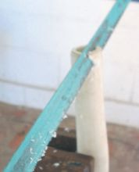 | 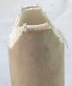  Note the double layer of pipe | 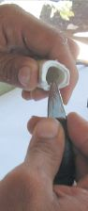 | 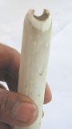
Cut off triangles, about 1 cm deep, from the reinforced end of the pipe. |  | Clean the cut edges with a knife, heat again, and bend the tips towards the inside.
This piece is strong enough to withstand the blows of the marble, yet it lets water pass freely.
Assembling the valve:
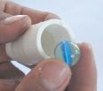 | 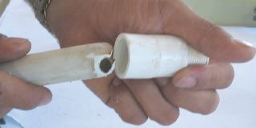 | 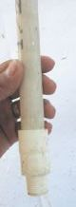
The marble sits in the extended male PVC adapter. | The “retainer” is glued into the adapter after putting in the marble. Make sure the marble can move up and down +/- 1 cm.
This same piece is made twice. One will become the piston valve, the other the footvalve.
The piston valve:
The piston valve is to be fitted with a rubber seal. We will make that from a piece of old car tyre.
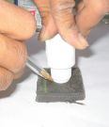 | 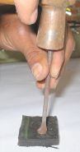 | 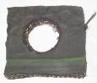 | 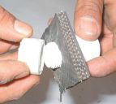 | 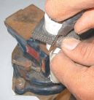
The hole in the rubber is made with a self-made chisel. You can also punch it out with a piece of sharpened ½” metal pipe. |  |  | The rubber is mounted onto the piston valve and kept in place by the thread we cut off the female adapter.
After cutting the seal roughly to size, it is reduced to its final size so it enters into the 1” pump cylinder pipe, using a metal file.
The footvalve:
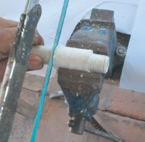 | 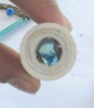 | 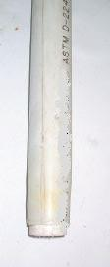 | The footvalve, mounted into the 1” cylinder pipe. Note that the valve is slightly narrower than the inner diameter of this pipe. Therefore, the cylinder end has to be reduced slightly, and the valve inserted with pressure.  Do not forget to glue the footvalve into the cylinder, as the water pressure might push it out.
Cut off both the pipe and the male thread from the valve. | Seen from above, the three layers of pipe (the inner ones from the retainer)
The handle guide:
The guide is a piece of 1” PVC pipe with “bells” at both ends. It guides the metal handle and prevents it from striking directly onto the PVC cylinder (which would otherwise wear out or break easily). The lower bell sits on the pump cylinder (and is fixed to it with a strip of inner tyre rubber).
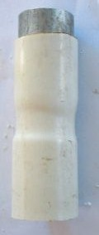 | In the upper end: a 3-4 cm piece of 1” iron tube (may be inserted completely).  2 “bells”  Total length: 10 cm.
The handle:
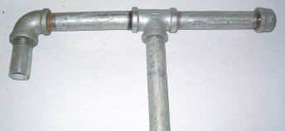 | 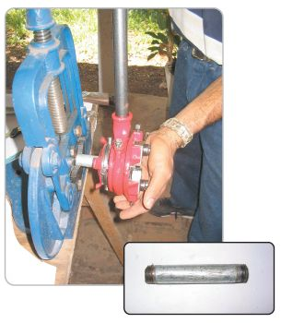
The handle is made of four ½” galvanized iron nipples (2 horizontal ones of 12-15 cm each, a vertical one of 80 cm and a spout of 3-5 cm), a galvanized elbow, a T and a cap.

Threading the ½” galvanized iron nipples
If electricity is available, the handle can also be welded. Yet, we will always need at least one thread, where the metal handle is threaded into a female adapter glued to the PVC piston pipe.
Assembling the pump:
Glue extensions of 1” PVC pipe to the cylinder to the desired length (so that the footvalve will always be at lesat 30-50 cm into the water, while the upper end will stick out at least 50 cm above ground level).

Lay the piston and the cylinder on the ground, side by side, with the handle guide mounted on top of the cylinder and the pump handle next to it, in the position where it will be when the pump is in rest position.

Make sure the lower end of the piston valve is 5 cm above the upper end of the footvalve (so the pressure chamber is at least 5 cm high). Now cut the piston to length (where the handle begins) and glue the female adapter (which will connect the piston to the handle) to the end of the PVC piston pipe.

Take the guide off the cylinder and put it over the handle. Then screw the handle into the female adapter at the end of the piston. (Note that the piston valve will not pass through the piece of metal pipe at the top of the guide. Metal pipes are thicker – their inner diameter is smaller – than PVC pipes.)

Photographs: PROCEDAMO, San Miguel, El Salvador, 2003.
Diagrams: TROPISEC, Estelí, Nicaragua, 1999.

Paul Cloesen, December 2007.
Annex 1. How to widen or reduce PVC pipe:

PVC pipe is quite malleable. It is easy to widen it (make a “bell” shape) by heating one end (without burning it), pushing another (not heated) pipe into the hot end and then cool it off in a bucket of water.
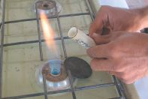 | 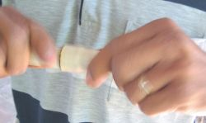
However, you cannot reduce a pipe by simply pushing a heated pipe end into another pipe. Instead of reducing its diameter, it will fold up. In order to reduce a PVC pipe, you have to push it deep into another one that already has a “bell”. The bell will guide the hot pipe end gently into the narrower part of the pipe beyond, and reduce its diameter without folding.

You will have to practice this oprocedure a few times before obtaining a neat reduction !

To make a piece of reinforced (double) PVC pipe (when building a retainer for a valve), reduce one end of a pipe, glue it into another piece of pipe and cut the non-reduced part off.

Annex 2. Materials and tools to build an EMAS pump (checklist):

Materials (for a 6m pump):  One ½” PVC tube, 6 m (SDR 13.5)  One 1” PVC tube, 6 m (SDR 26)  Three ½” female PVC adaptors  Two ½” male PVC adaptors  Two glass marbles  PVC glue  One (worn) car tire  One 1” iron tube, 3-5 cm  One ½” galvanized iron nipple, 80 cm  Two ½” galvanized iron nipples, 12 cm  One ½” galvanized iron nipple, 5 cm (threaded at one side only)  One ½” galvanized iron T  One ½” galvanized iron closing cap  One ½” galvanized iron elbow  One ¾” garden hose, 2 m, to connect the pump to distribution piping (optional) | Tools:  Piece of thick iron or aluminum sheet metal  Steel brush (to clean the former after use)  Metal file  Pliers  Metal hacksaw  Knife  Hammer  Self-made chisel (from a ¼” concrete iron)  Bucket with water  Threading tools  Measuring tape (optional)  Pipe wrench (optional)  Working table  Table press  Tube press  Gas stove (optional)

In this example we work with ½” adaptors and an ordinary marble. But in the same way we can use bigger ¾” adapters and a bigger marble to get a bigger pump with larger output. Such pump may be better for very shallow wells. It is however, heavier to pump with and hence less suitable for children.

