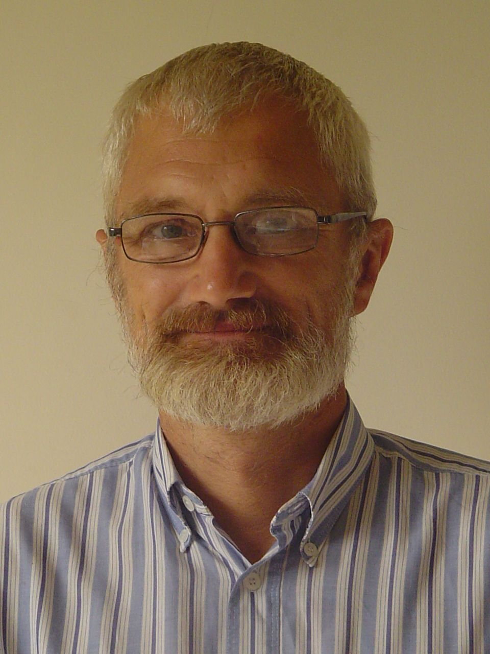
Curriculum vitae
(February 2013)
- Family name: Cloesen
- First names: Henri-Paul Gustaaf Marie
- Date of birth: 16/07/1959
- Nationality: Belgian
- Civil Status: Divorced, two sons.
- Education:
Institution from - to | Degree(s) or Diploma(s) obtained:
KULeuven, Belgium,  1978-1984 | “Landbouwkundig ingenieur” - eq. MSc. Agronomy (Plant Breeding / Agronomy of Tropical and Subtropical Regions)
- Language skills: Indicate competence on a scale of 1 to 5 (1 - excellent; 5 - basic)
Language | Reading | Speaking | Writing
Dutch (mother tongue) | 1 | 1 | 1
English | 1 | 1 | 1
Spanish | 1 | 1 | 1
French | 1 | 1 | 1
Sranantongo | n.a. | 3 | n.a.
German | 2 | 3 | 4
Portuguese | 2 | 5 | 5
- Membership of professional bodies: KVIV (Association of Flemish Academic Engineers)
- Other skills: (e.g. Computer literacy, etc.)
- Word Processors, Spreadsheets, Database Managers and Geographical Information Systems
- Image processors, Auto-CAD; HTML
- Development of Management Information Systems; Programming languages: VB, VBA and VBS
- Present position: Researcher-consultant
- Years within the firm: 1
- Key qualifications:
- Management, Monitoring and Evaluation in International Cooperation (Multilateral, Bilateral, & NGO), covering rural development, food security and environment, either in direct execution, through a participative “facilitating” approach or as Grant Schemes.
- Procurement & Contracting of Supplies, Services, Works & Grants under EU PRAG (EDF and Budget).
- Project Cycle Management: Identification, Formulation, Planning, Monitoring and Evaluation (UN & EU), including SWOT analysis, Logical Framework, Value Chain Approach, budgeting etc.
- Feasibility studies, including economical, social and environmental impact assessments.
- Technical Assistance to government, non-state actors, civil society as well as farmers' organisations.
- Training of trainers, development of training materials, workshops & seminars, curriculum development.
- Design and implementation of sustainable rural (micro-) Savings and Loans programmes; risk management.
- Design and development of Management Information Systems.
- Economic diversification, increase of added value and development of marketing channels.
- Sustainable (self-built) water supply systems: well drilling and building of pumps and sanitation systems.
- Agronomy of most important tropical crops under different management systems and ecological conditions. Thorough knowledge of the oil palm / palm oil sector: cultural practices, plant protection, genetic improvement, plantation management, small scale processing and recycling of industrial waste.
- Specific experience:
Country | Dates: from - to | Country | Dates: from - to
Belgium | 03/1993-03/1994; 11/1999-03/2001; 2013 | Guinea Bissau | 04-05/1994
Belize | 04/2009-06/2010 | Honduras | 03/2003; 11-12/2007; 09/2011 - 04/2012
Cameroon | 08/1993; 03-04/1994 | Italy | 08/1989-02/1990
Colombia | 07/2005 | Nicaragua | 03/2001-12/2002; 2004 … 2010 (39 missions)
Costa Rica | 02/1990-04/1993; 2007,08,10,11,12,13 | Nigeria | 02-07/1988; 05-06/2008
Ecuador | 07-08/2007 | Papua New Guinea | 12/2006
El Salvador | 07-10/2003; 11-12/2007 | Peru | 02-04/1996; 01-03/2005
Gabon | 09/1988-08/1989 | Saudi Arabia | 07-11/1987
Guatemala | 08/1994-11/1999 (LT & missions); 02 & 04-05/2001; 10/2003-11/2004 | Suriname | 12/1984-05/1987; 1992 & 11-12/1994
Guatemala |  | Turkey | 08-11/2006; 03-05/2007

- Professional experience:
Date from - to | Location | Company & Reference Person | Position | Description
01-2013 - present | Belgium & Costa Rica | CDR, San Pedro de M.O., Costa Rica  Mr. Hans Nusselder (506) 22 24 19 90 hnusselder@cdr.or.cr | Researcher-consultant | Rural research and consultancy, covering peasant economics and rural institutions; financial and commercial instruments for income stabilisation and food security and sustainable agriculture.
10-2012-present | Costa Rica | UNED (Distance University)  Prof. Jorge Luis Hernández  jorgedezca@gmail.com | Researcher (ad honorem) | Support to a study on family based agriculture in Costa Rica.
04/2012-present | Costa Rica | n.a. (own initiative) | Engineer | Design and implementation of a wastewater recycling plant in a car wash.
04/2012-08/2012 | Costa Rica | University of Costa Rica  Dr. Eric Guevara (506) 25 11 87 31  eric.guevara@ucr.ac.cr | Researcher (ad honorem) | Preparation of a course on biofuels.
09/2011 - 04/2012 | Honduras | GOAL, Dublin, Ireland  Mr. Bernard McCaul (504) 89 91 01 19  bmccaul@hn.goal.ie | Regional Director, Gracias a Dios | Coordination of disaster preparedness, environment conservation, rural infrastructure and SME development projects with EU (DIPECHO, FORCUENCAS), USAID, UN and IDB financing.
10/2004-08/2011  (39 missions) | Nicaragua | n.a. (own initiative) | Technical Director | Training of trainers for self-reliance in rural water supply. Manual well drilling; rainwater harvesting, simple water pumps, hydraulic rams, water distribution and sanitation systems. Formulation and management of internationally financed projects. Search for funding. Development of a website and cartography of the area.
04/2009-12/2010  (LT and ST) | Belize and Costa Rica (home) | INTEGRATION, Frankfurt; EU - Belize Accompanying Measures for Sugar;  Mr. Calin Grigorean (49) 69 91 33 430 cgrigorean@integration.org | Finance Manager/ Procurement / Contracts Specialist;  Team Leader a.i. | Training in preparation of tender dossiers and contracting of Services, Supplies and Works; Calls for Proposals for Grants under EC PRAG; Drafting of ToR; Training of government officials and local organisations in tendering and drafting of Grant applications; Programme monitoring and coordination; Final report.
09-10/2008 | Costa Rica | AGRER S.A., Brussels  Mr. Eddy Wellens (32) 16 89 34 11 eddy.wellens@telenet.be | Consultant, Tendering | Drafting of the methodology in a bid for a UE Project on Solid Waste, Water Supply and Sanitation in northern Cyprus.
05-07/2008 | Nigeria | HVA International, A'dam  Mr. Ype Verhey (31) 20 31 16 000 dbverhey@hvainternational.nl | Consultant, Oil Palm Development | Fact-finding/feasibility mission on rehabilitation and extension of two Oil Palm Estates: agronomical, field management and environmental aspects, potential yield estimation and dimensioning of the mill.
11-12/2007 | Honduras and El Salvador | ECF SpA, Venice, Italy  Mr. Giovanni Cappé (39) 06 90 14 62 36 g.cappe@ecfspa.com | Consultant, Programme Evaluator | Mid-Term Evaluation of the “Programa Binacional de Desarrollo Fronterizo Honduras – El Salvador” (ACR/IB-2000/2052). Components: Rational Use of Natural Resources & Environmental Protection.
07-08/2007 | Ecuador | Flemish Association for Education Programmes Overseas (VVOB), Brussels  Mr. Wouter Van Damme (32) 2 209 07 86 Wouter.VanDamme@vvob.vlaanderen.be | Consultant, Project Evaluator | Final Evaluation of two co-operation projects with universities on improvement of competitiveness of SMEs through “cleaner production” and food safety (ISO norms 9000, 14000, 17000 and 22000; OHSAS 18000).
05-06/2007 | Costa Rica | BIOTEC S.A., Belgium & Colombia  Mr. Philippe Conil (57) 2 325 98 29 philippe.conil@bio-tec.net | Consultant, Ferti-irrigation | Feasibility study on anaerobic digestion of pig farm and slaughterhouse effluent and recycling of plant nutrients in agriculture.
03-05/2007 | Turkey | AGRER S.A., Brussels; EU - RD AKKM  Mr. Robert Couturier (32) 2 640 63 10 robert.couturier@agrer.com | Consultant, Agricultural Extension;  Team Leader a.i. | Programming Farmers’ training; Preparation of curricula and training materials; design of Monitoring and Evaluation tools. Technical Assistance to procurement activities under the Grant Scheme at the RD AKKM programme.
12/2006 | Papua New Guinea | TRANSTEC S.A., Brussels; EDF - 9 ACP PNG.002  Mr. Sylvain Schultze (32) 2 266 49 87  sschultze@transtec.be | Consultant, Financial Management & Database Programming | Development of software for financial monitoring of commitments under EDF financing.
08-12/2006 (3 missions) | Turkey | Scott Wilson Ltd., UK; EU – RD SKE  Mr. Martin Edge (44) 12 56 31 04 40  Martin.Edge@scottwilson.com | Consultant, Procurement | Training of trainers on procurement of Works, Services and Supplies under EU rules. Development of a Monitoring System and tender dossier generation software.
07/2005 | Colombia | BIOTEC S.A., Colombia and Belgium;  Mr. Philippe Conil (57) 2 325 98 29 philippe.conil@bio-tec.net | Consultant, Oil Palm Ferti-irrigation | Pre-feasibility assessment on recycling nutrients from the effluent of a palm oil mill into plantations: economic, agronomic and environmental aspects.
03/2005 | Peru | AFC GmbH, Bonn;  EU-PER/B7-310/IB/98/0253 - PRODAPP Mr. Jochen Ressmann (49) 228 985 79 0  Ressmann-J@consultants-bonn.de | Consultant, Oil Palm Development | Feasibility study: Establishment of Oil Palm Agro-industrial Complex in a coca growing region. Agronomical, economical and social aspects.
10/2003 - 11/2004 | Guatemala | EPTISA, Madrid;  EU - GTM/B7/-3010/95/202 - PDPII  Mr. Stefano Cominelli (34) 91 559 51 52  scominelli@eptisa.com | Expert, Technical Assistance in Productive Activities | Planning and monitoring of productive projects in relocated communities, product of civil war. Tendering, contracting, follow-up and evaluation of studies, works and legalisation of Land Tenure. Preparation of Co-operation Agreements with local NGO's. Monitoring and Evaluation of Credit portfolios / Trust Fund.
08-10/2003 | El Salvador | HTSPE Ltd., Hemel Hempstead, UK;  EU - PRRAC PROCEDAMO  Mr. Peter Wachowski  p_wachowski@yahoo.de | Consultant, Project Planning, Monitoring and Evaluation | Development of Monitoring and Evaluation software for the Project's counterpart institutions. Support to the formulation of the last Annual Action Plan and the draft for final hand-over. Training of end-users in counterpart institutions.
03/2003 | Honduras | IBF S.A., Brussels;  EU - PRRAC Desarrollo Local  Mr. Bernard Basteyns (32) 2 237 09 00  bernard.basteyns@ibf.be | Consultant, Monitoring and Evaluation | Development of a computerized Monitoring and Evaluation system for Activities, Results and Objectives of the Project, conform its Logical Framework.
03/2001- 12/2002 | Nicaragua | BDPA S.A., Paris; EU - NIC/B7-310/98/156 - Proyecto Zona Norte | Expert, Economic Diversification, Trade and Rural Credit | Promotion of economic alternatives for a region over-dependent on coffee growing: crop alternatives and (eco-) tourism. Subcontracting of services. Formulation and implementation of a sustainable rural credit programme. Development of software.
02-03/2001 and 05/2001 (2 missions) | Guatemala | SOPEX S.A., Antwerp, Belgium; EU - GUA/B7-2120/97/17 - Proyecto Ixcán  Mr. Christian Vd Sompel (32) 3 285 39 77  info@sopex.be | Consultant, Rural Credit | Formulation of a sustainable Rural Credit programme; negotiation of a Trust Fund Administration Contract with Banks and terms of collaboration with local Intermediaries. Formulation of rules and strategies for sustainability.
03/2000-03/2001 | Belgium | Luxconsult S.A.,Luxemburg;  EU - TACIS Procurement Unit  Mr. Jean-Pierre Staus stausjp@pt.lu | Contracts Expert | Organisation of the launch, processing and evaluation of Services and Works tenders. Preparation and follow-up of EU contracts and their addenda.
07/1999-03/2000 | Belgium | Borealis, GEOS and AG, Wellen, Alken and Brussels | Consultant, Software Development | Development of application software and software quality control.
08/1994-1999 (LT and ST) | Guatemala | AGRER S.A., Brussels; EU - ALA 91/21  Mr. Robert Couturier (32) 2 640 63 10 robert.couturier@agrer.com | Area Manager and Consultant, Rural Development and Credit; Team Leader a.i. | Project co-ordination. Rural Infrastructure, Social Organization and Productive activities. Implementation of a Rural Credit Programme. Strengthening of the local intermediary organisation and advice to its management. Negotiation of extensions to the Trust Fund Administration Contract.
01/1997-12/1998 | Guatemala | COTECNO Srl., Rome; EU - GUA/B7-3020/95/22 - PDP; Mr. J. Mario Mannino (39) 06 6873406;jm.mannino@cotecno.org | Consultant, Rural Credit | Four Missions: Formulation of a Rural Credit Programme and implementation of credit management and monitoring software.  Organisation of seminars and workshops and training of staff
02-04/1996 | Peru | INDE S.A., Lisbon;  EU - ALA 88/17 - Pampa II | Consultant, Project Formulation | Formulation of Global and Annual Action Plans for the second phase of a Rural Development Project. Infrastructure and Rural Credit.
11-12/1994 | Suriname | FAO, AGP Division, Rome | Consultant, Project Formulation | Formulation of a Selection and Inter-specific Breeding Programme aimed at resistance to Fatal Yellowing in Oil Palm.
04-05/1994 | Guinea Bissau | FAO, AGP Division, Rome | Consultant, Oil Palm Germplasm | Germplasm collection for genetic improvement of drought resistance in Oil Palm  .
03-04/1994 | Cameroon | SOCFINCO S.A., Brussels | Consultant, Project Formulation | Feasibility study for an Oil Palm Agro-Industrial Complex.
08/1993 | Cameroon | UNCTAD, Geneva | Consultant, Palm Oil | Formulation of a project for small scale palm oil extraction.
07/1993 | Belgium | FAO, Forestry Division, Rome | Consultant, Management Information Systems | Evaluation of a Forest Management Information System.
02/1992-04/1993 | Costa Rica | FAO, various projects | Consultant, Management Information Systems | Design and Implementation of Management Information Systems.
03/1990-02/1992 | Costa Rica | FAO, Representation in Costa Rica | Programme Officer | Operational Monitoring of Projects and FAO Regular Programme activities. Development administrative automation software
09/1989-02/1990 | Italy | FAO, Rome | Associate Expert | Monitoring of field projects and implementation of a variety performance database for horticultural crops.
09/1988-08/1989 | Gabon | FAO, Rome | Technical Adviser | Rehabilitation of provincial agricultural research stations. Introduction and multiplication of adapted varieties of food and fruit crops.
02-07/1988 | Nigeria | SOCFINCO S.A., Brussels | Study Engineer | Feasibility studies on rehabilitation and expansion of Oil Palm plantings.
07-11/1987 | Saudi Arabia | Hortimar Al Alami Est. and SAFRAGREX S.A., Riyadh | Project Manager | Production of vegetables in a high-tech greenhouse environment. Maintenance of desalinisation, electricity generation and irrigation installations and equipment
05/1985-05/1987 | Suriname | L.M. Victoria N.V., Paramaribo | Head Agric. Research; Field Manager | Applied Research on phyto-pathology and cultural practices in Oil Palm.  Overall management of field operations in an Oil Palm Estate.
12/1984-04/1985 | Suriname | Seventh Day Adventist Mission, Paramaribo / Belgian Co-operation | Project Manager | Introduction of horticulture in an indigenous village.  Marketing of vegetables on local markets.

- Other relevant information (e.g. Publications):
- Mathematical proof of contagiousness of Fatal Yellowing 'Disease' in Oil Palm through comparison of linear and exponential regressions. (Dutch, L.M. Victoria N.V., Surinam, 1985)
- Comparison of different insecticides applied into the crown of Oil Palms to combat Castnia daedalus stem borers. (Dutch, L.M. Victoria N.V., Surinam, 1986)
- On the advantages of Surinamese Elaeis oleifera as a parent for Fatal Yellowing resistant Oil Palm hybrids in Surinam. (Dutch, L.M. Victoria N.V., Surinam, 1987)
- On cultural practices and economy in Oil Palm smallholdings in South-East Nigeria. (English, SOCFINCO S.A., Nigeria, 1988)
- On the growing of 'Atom' (Dacryodes macrophylla (Oliv.) Lam., Burseraceae) and 'Mvut' (Trichoscypha acuminata / T. ferruguinea Engl., Anacardiaceae), wild fruit species, in the nursery stage (French, FAO CIAM project, Gabon, 1989)
- Software and corresponding manuals for Database Management, Management Information and Geographical Information Systems; statistical, mathematical and economic analysis; document workflow, covering Irrigation Management, Savings and Credit Schemes, International Tender preparation, HR Management, Insurance, Laboratory results, Environmental Indicators etc. (Spanish, English, French and Dutch, 1991-present)
- "The Interspecific Hybrid Elaeis oleifera x E. guineensis : A solution for the Surinamese Oil Palm Industry." (Literature study, 1992 in: “De Surinaamse Landbouw”, 1995)
- "Pilot Scale Replanting of Spearrot Devastated Oil Palm Plantations with Interspecific Hybrids." (English, TCP project proposal, FAO, AGP Division, 1992, 1995 and 1997)
- "Pre-feasibility Study on the Establishment of Micro Palm Oil Mills in Cameroon." (UNCTAD, Geneva, 1993)
- Co-author of a feasibility study on the establishment of a palm oil agro-industrial complex on the Lokoundjé river: socio-economical and agronomical aspects. (French, SOCFINCO-Terres Rouges, Cameroon, 1994)
- "Collection of Drought Tolerant Oil Palm Germplasm in Guinea Bissau." (English, FAO Project TCP/IND/2358, 1994)
- Co-author of Global and Annual Action Plans for the second phase of the project PAMPA II, Puno, Peru: Infrastructure and Rural Credit. (Spanish, European Union, DG1, Brussels, 1996)
- “The Use of Information and Communication Technology in Micro-Enterprise Development”; “Alternative Risk Assessment and Guarantee Mechanisms, Adapted to the Very Poor.”; “Bridging the Gap Between Rural Micro-Enterprise and the Formal Banking System.” (English, in: "Best Practices in Micro-Enterprise Development", IIRR, Philippines, 2000)
- “Semilla de Higuera Genera Ingresos”, on the potential of Castor Beans (Ricinus communis) as an Economic Alternative in Nicaragua. (Spanish, in: La Prensa, Nicaragua, 17/12/2002)
- Annual Action Plan 2004 and Final Handover Proposal for PROCEDAMO (Spanish, European Union, PROCEDAMO, El Salvador, October 2003)
- Co-author of Annual Action Plan 2004 for PDP II (Spanish, European Union, PDP II, Guatemala, March 2004)
- “Estudio de Factibilidad de Plantación de Palma Aceitera en la Provincia Puerto Inca, Departamento Huánuco, Perú.” Feasibility study on the establishment of smallholder Oil Palm plantations. (Spanish, European Union.; PRODAPP, Peru, March 2005)
- Feasibility of ferti-irrigation with anaerobically digested Palm Oil mill effluent. (Spanish, Biotec S.A., Colombia, 2005)
- “Comité Si a la Vida, No a la Destrucción del Medio Ambiente” (website of a local environmental pressure group, Spanish and English, 2004-2006)
- Feasibility of ferti-irrigation with anaerobically digested piggery and slaughterhouse waste (English, Biotec S.A., Costa Rica, 2007)
- Evaluation Reports on international cooperation projects (Spanish, VVOB & EC, 2007)
- Introductory articles on Manual Well Drilling Methods (RWSN and Wikipedia, 2007-2008)
- Rehabilitation of the Ihechiowa Oil Palm Plantation (English, HVA, Nigeria, 2008)

